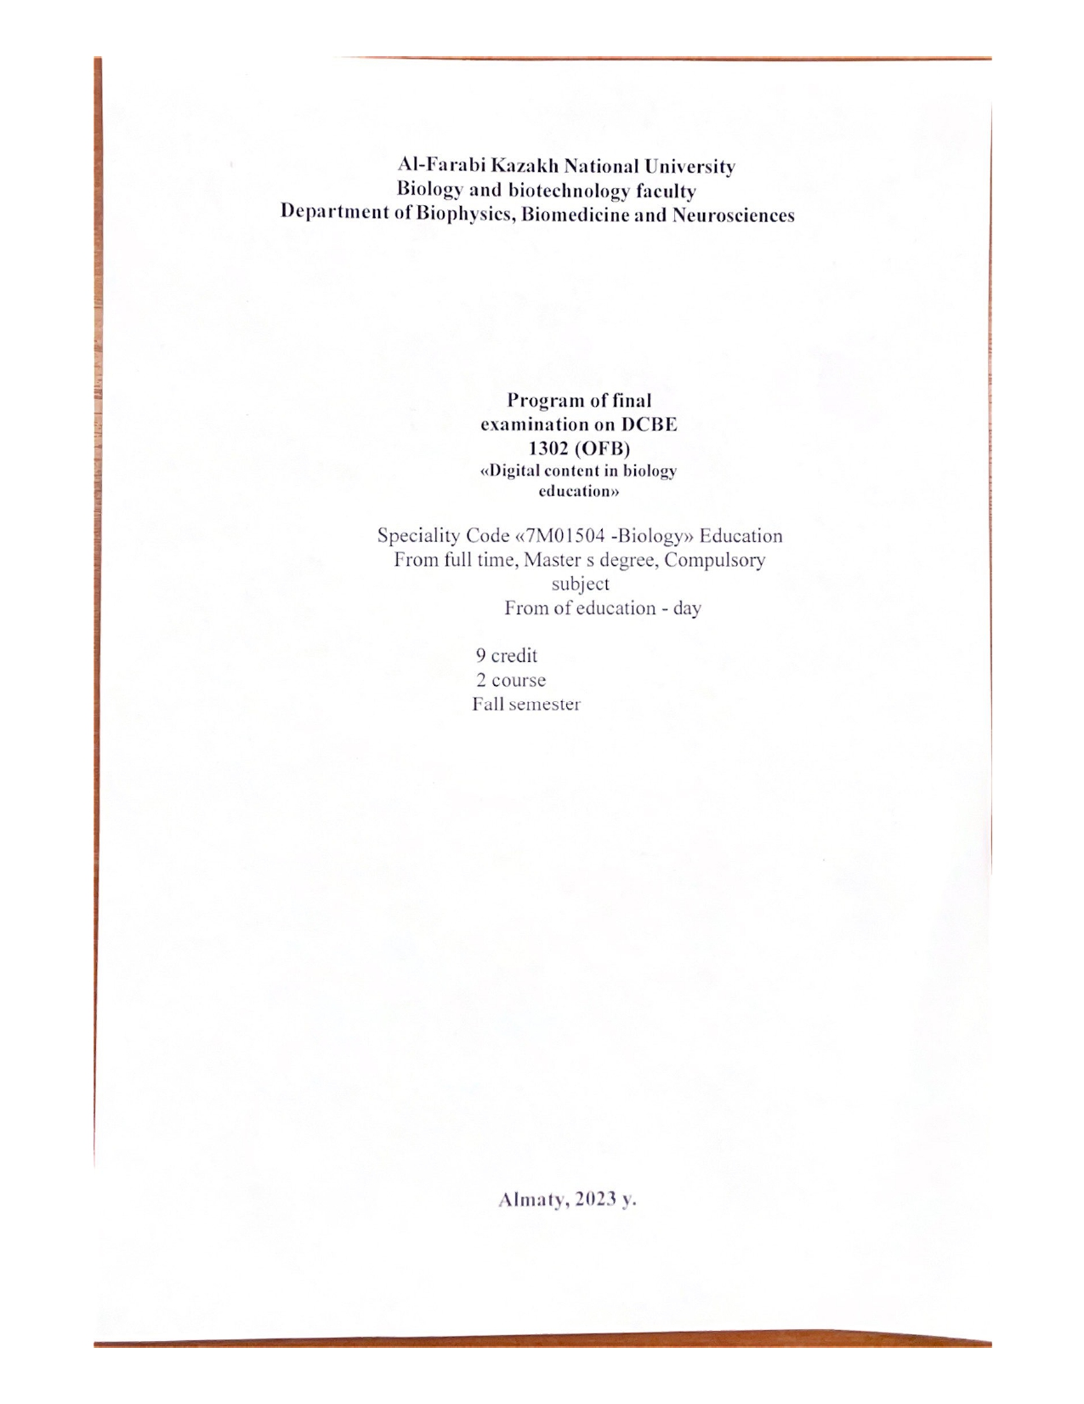
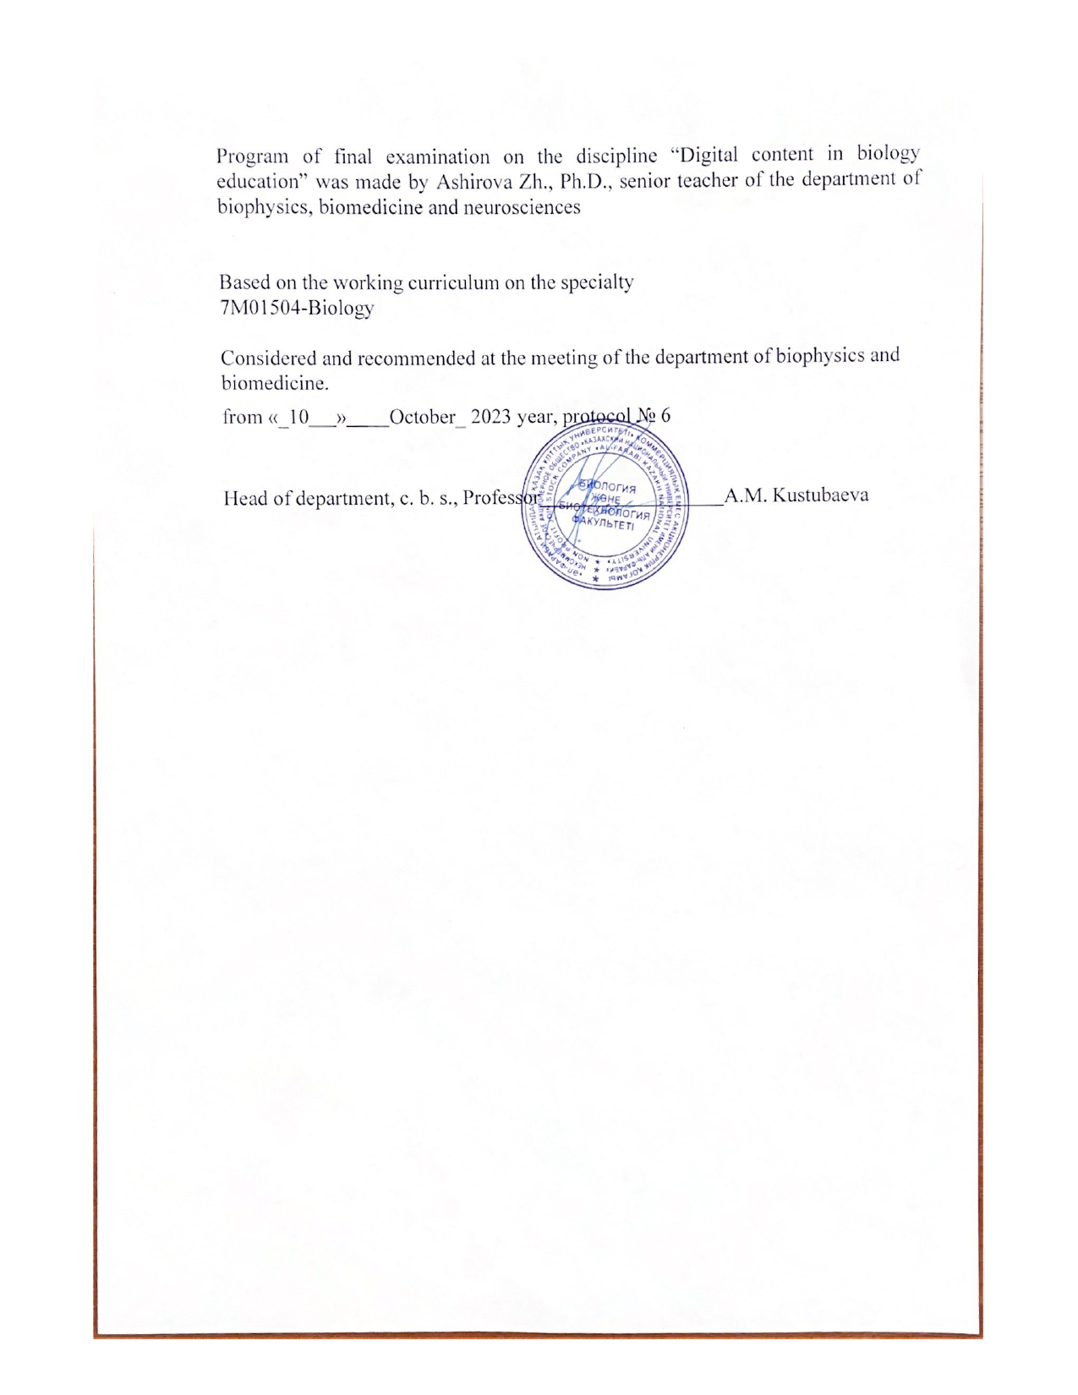
The KAZAKH NATIONAL UNIVERSITY of al-Farabi
Faculty biology and biotechnology Methodological recommendations for Final Exam
« DCBE 1302 » - « Digital content in biology education » Exam Type: On univer system test (Quiz)
Inform students of the purpose and parameters of the Final Exam (Quiz)
Clearly communicate with students about what your goals are for any test or exam. Test questions consist of choosing one, two and three answers. Don't assume that students know what the pedagogical purpose of the test or exam is. Have a discussion about your goals and desired outcomes, and help students understand how specific aspects of the test or exam fit these goals. Be open to making some changes if students have ideas to offer.
Point out the important sections in course plans, textbooks, and readings to guide test and exam preparation; where possible, provide multiple samples of tests and exam questions and answers. Although you might not provide students with exam questions in advance, you should be prepared to answer questions such as:
- What will the exam cover?
- How much emphasis should I put on the textbook / lectures / etc…?
- What material (if any) am I allowed to bring into the exam room?
- When will I get my mark?
- What happens if, for a good reason, I can’t attend the exam? Do I get to re-write?
- Will I be given the chance to choose the topics on which I do questions?
- Will I be told which criteria I am being assessed on?
- If I disagree politically or philosophically with the marker, will I get poor marks?
- Will allowances be made if English is not my first language?

PREPARING TESTS (METHODOLOGICAL RECOMMENDATIONS)
With all these characteristics, it is no wonder that multiple choice tests are both under-estimated by some students and revered by others. We begin with a series of in-test strategies and then apply these to a few example questions, highlighting the structure and purpose of each question. When appropriate, we mention additional preparation strategies that could be used to prepare for the questions:
- Preview the exam.
As you browse through, take note of those questions which seem easier (i.e., those questions you think you can answer) and perhaps plan to skip those which seem harder, setting time limits, and getting settled; keep to time divisions for questions as they are usually equally weighted
- Start with questions you can answer readily.
Don't waste time labouring over troublesome questions at the start. Be sure to get credit for items you know well.
- Recycle through the test.
Now try the questions you could not do on the first attempt. Sometimes the answer will occur to you simply because you are more relaxed after having answered other questions. Sometimes, too, your answer to one question provides a clue to the answer of another.
- Set goals for time and pace yourself accordingly.
Allocate your time according to the relative worth of questions. Try to save a few minutes at the end for review and revision. Remember: your first answer may not always be your best answer. Change answers, but only if you have a good reason for doing so.
For instance, changing an answer from, say, selection "b" simply because your response

to the previous four questions was also "b" and you cannot believe that five questions in a row would have the same item as the correct response, is likely not a good reason; be flexible in your approach.
- Read the questions carefully, twice if necessary.
Avoid jumping to conclusions about what you think the question asks.
- Circle or underline key words in questions.
Multiple choice tests examine your ability to read carefully and thoughtfully as much as they test your ability to recall and reason. Watch for words like "all," "always," "never," "none," "few," "many," some," "sometimes."
- Try to recall a concept from memory or think out the answer before looking at the options.
Doing this successfully may help you "wade through" the alternatives and find a reasonable answer or choice.
- Consider the cover-up strategy.
Read the question and try to answer it by recall before looking at the alternative answers.
- Consider the true/false label strategy.
Label the alternative answers as true or false statements and then look for a pattern in the answers
- Sometimes alternatives differ by only one or two words or in the order of one or two terms.
These can seem very confusing. It helps sometimes to read the stem of the question (that's the question part) with an alternative while covering up the others. By methodically thinking through the alternatives this way, you may be able to make more sense of the options by labelling them true or false and eliminating those that don't correctly complete the question.
- Use the hint of highly similar pairs.
Often the answer is imbedded in one of two very similar pairs and the "most correct" answer is often the one that correctly uses course terminology; consider the all or none of the above cues — if two of the preceding alternatives are opposites then one of them and the all or none of the above choice is also wrong.
- Be prepared to change your answer
... if you can determine a clear reason why your first response is incorrect. Many students report difficulties arising from changes that are made on the basis of nervous feelings.
- You might want to try to answer all the questions from the same section of the course
to offset the mixing of questions inherent in the design of the test -- this demands care be taken that answer sheets are correctly completed and that all questions have been answered; consider guessing when there is no penalty for a wrong answer.
- Be alert to terminology which links the alternatives or questions to key areas of the course, lectures, or chapters of a course's materials.
This may help you narrow the field of possible choices and think through to the best answer.
- Be wary of descriptive words which are overly exclusive or overly inclusive.
These absolute terms tend to portray things as right or wrong where this is often not the case. Words like always, never, completely, and only are absolutes. Relative words like often, usually, seem and may are often more accurate.
- Translate double negative statements into positive ones.
Examples like "Not lacking" or "not none" become "having" and "some" and this can reduce confusion. Note that these are often partly in the stem and partly in the choices of a particular question.
- If you must guess, look for some of these possibilities:

  - the style of an answer option is very different from all of the others - this may disqualify it;
  - the grammar of the question stem is not in agreement with the grammar of an alternative;
  - some alternative is not in the area or topic of the question, but comes from some other part of the course- this may disqualify it.
Overall, remember that you are looking for the best answer, not only a correct one, and not one which must be true all of the time, in all cases, and without exception.

Simple of quiz
1. The purpose, objectives and relationship of the subject of digital content in biological education with other sciences
2. To determine how and why digital technologies in biological education can be used in their practice, with reference to relevant concepts,
Principles and theories
3 Potential of digital technologies in education, methods of statistical control of the quality of Education
4. Development of principles and concepts related to the use of digital technologies in biological education (using the example of Microsoft word)
5 Features of the use of digital technologies in the school, the development of skills of the XXI century among students
6. Understand the problems associated with the use of digital technologies in biological education and apply them in their own practice (using the example of Microsoft excel)
7. «Development of scientific publications on Master's topics using Microsoft programs»
Project work – use any example of your report as a Master peace
Demonstrate at any available program.
8. Features of the use of digital technologies in biology lessons
9. Planning, preparing and conducting classes using one or more
digital technologies
10. Colloquium – logical task
Development of glossary of the course material.

11 The importance of using digital technologies in active and inclusive learning
12 Demonstrate how you can develop an active learning and inclusive learning environment using digital technologies, as well as engage and motivate students to learn.
13. Stages and concept of composition of the electronic textbooks
14 Research of electronic textbook compiling programs
15 Different tools for writing an e-book
16 Drawing up the content of an electronic textbook
17 Ways to add and edit video and audio recordings to an e-book or texts
18. Adding and editing video and audio recordings to an e-book or texts
19 Formation of information and communication competence in biological education
20 Selection of appropriate digital technologies for the design of learning activities specific to the development of different skills
21 Psychology of personality and interpersonal relationships in biological education using digital technologies
22 Identify strengths and directions in designing educational
23 SMART Learning technology in biological education
24 Collaborative environment choosing the most effective form of lesson organization
25 Review of the methodology and system of distance learning, Mass Open Online Courses
26 Analysis of modern technologies of online events
27 Use of multimedia technologies in biological education
28. Intensification of the educational process using multimedia technologies in biological education
29 Assessment of students' knowledge using digital technologies in biological education (Quiz programs)
30 Working with the Free Quiz Maker program
31 Colloquium Make a structural and logical diagram of the read material – logical task
32 Features of working with Converter programs in biological education
33 Working with Freemake Video Converter

Evaluation criteria
Below are the minimum scores in percentages:
95% - 100%: A 90% - 94%: A-
85% - 89%: B+ 80% - 84%: B 75% - 79%: B-
70% - 74%: C+ 65% - 69%: C 60% - 64%: C-
55% - 59%: D+ 50% - 54%: D- 0% -49%: F

EVALUATION CRITERIA

"EXCELLENT" - the student has knowledge of the subject in the full scope of the curriculum, comprehends the discipline deeply enough; independently, in a logical sequence and exhaustively answers all the questions of the ticket, while emphasizing the most essential, is able to analyze, compare, classify, generalize, concretize and systematize the studied material, highlight the main thing in it: establish cause-and-effect relationships; clearly forms answers, freely reads the results of analyzes and other studies and solves situational problems of increased complexity; familiar with the main literature

"GOOD" - the student has knowledge of the discipline in almost the entire scope of the program (there are gaps in knowledge only in some, especially complex sections); does not always highlight the most significant, at the same time does not allow serious errors in the answers; able to solve light and moderate situational problems; is able to interpret laboratory and instrumental studies in excess of the mandatory minimum.

"SATISFACTORY" - the student owns the main body of knowledge in the discipline; shows difficulty in independent answers, operates with inaccurate formulations; in the process of answering, mistakes are made on the merits of the questions. The student is able to solve only the easiest problems, owns only the mandatory minimum of research methods.

"UNSATISFACTORY" - the student has not mastered the required minimum knowledge of the subject.

References
- Teaching and Digital Technologies: Big Issues and Critical Questions Paperback. January 8, 2016 by Michael Henderson (Editor), Geoff Romeo (Editor)
- Biancarosa, G., & Griffiths, G. C. (2012). Technology tools to support reading in the digital age. The Future of Children, 22(2), 139-160. http://www.jstor.org/stable/23317415?seq=1&cid=pdf- reference#page_scan_tab_contents
- Forsyth, E. (2016). Using videoconferencing for professional development and meetings. Computers In Libraries, 36(7), 11-14.
- Remis, K. K. (2015). LMS enhances K12 instruction: Systems increase engagement, provide quick access to digital resources and help teachers with administrative tasks. District Administration, Digital Edition, May 27, 2015. http://www.districtadministration.com/article/lms-enhances-instruction
- Dominic, M. (2016). Handbook of Research on Mobile Learning in Contemporary Classrooms. Hershey, PA: IGI Global.
- Korakakis, G. G., Pavlatou, E. A., Palyvos, J. A. and Spyrellis, N. N. (2009) “3D visualization types i n multimedia applications for science learning: A case study for 8th grade students in Greece”, Computer s & Education, Vol 52, pp 390‐401.

